Encompassing American Indian Culture in Healthcare
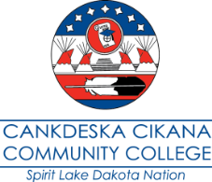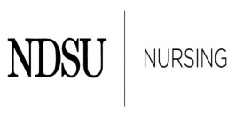
Thursday, May 28, 2015, Holiday Inn, Fargo, North Dakota
Friday, May 29, 2015, Holiday Inn, Fargo, North Dakota

Registration Form
Registration deadline May 26, 2015

First name: Click here to enter text.
Middle name: Click here to enter text.
Last name: Click here to enter text.
Address: Click here to enter text.
City: Click here to enter text.
State: Click here to enter text.
Zip code: Click here to enter text.
E-mail address: Click here to enter text.
Phone number: Click here to enter text.
Name of company: Click here to enter text.
Job title: Click here to enter text.
Will be attending full conference ☐
Will be attending one day ☐
Which day? Click here to enter text.

Registration form submission options:
Email to - Loretta.heuer@ndsu.edu,
Mail to - Loretta Heuer, PhD, RN, FAAN, North Dakota State University, Department of Nursing
Department 2670, PO Box 6050 / Fargo ND 58108-6050, or
Fax to - 701.231.6257

For questions please call Loretta Heuer at 701-231-8205 or 701-238-8484

