John Gonzalez, PhD - Bemidji State University

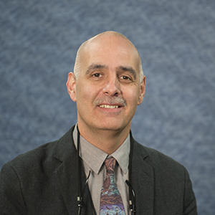
Dr. John Gonzalez is from the White Earth Anishinaabe Nation and an Associate Professor of Psychology at Bemidji State University, where he also received his undergraduate degree in psychology. He received his PhD in Clinical Psychology from the University of North Dakota. Dr. Gonzalez’s professional interests are in cultural psychology, multicultural psychology, and community psychology. All of these areas come together to provide a holistic view of people and their environments. Dr. Gonzalez’s research interests are in the areas of mental/behavioral health for indigenous people and ethnic minorities. He has worked with Indigenous communities utilizing local cultural knowledge and values in developing suicide and substance abuse prevention programs. More recently, Dr. Gonzalez has investigated the racial experiences of American Indian students and Native people’s racial experiences accessing healthcare.

