H. Bruce Vogt, MD, FAAFP - University of South Dakota

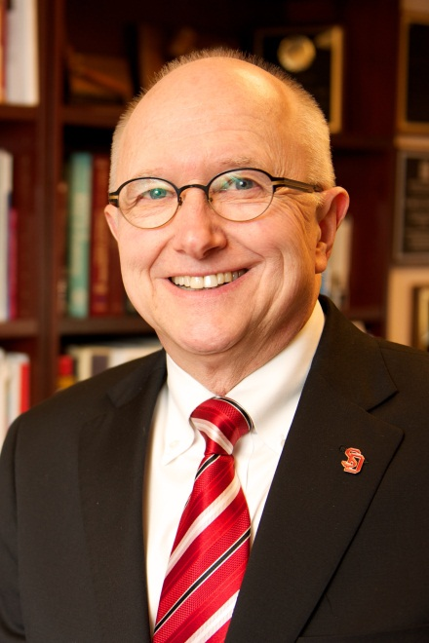
3H. Bruce Vogt, MD, FAAFP, is Professor Emeritus and Former Chair of the Department of Family Medicine of the USD Sanford School of Medicine (USD SSOM). He also continues to serve as the Medical Director for the USD Physician Assistant Studies Program. Dr. Vogt is a native of Yankton, South Dakota. His undergraduate degree is in Biological Sciences from the U. of South Dakota. His fi rst two years of medical school were completed at USD and he received his medical degree from the U. of Nebraska College of Medicine. He completed his family medicine residency at the Sioux Falls Family Medicine Residency Program (SFFMRP). Following four years in private practice, he joined the faculty of the SFFMRP in 1981. In September of 1989, Dr. Vogt was named Dean of Graduate Medicine Education for the USD SSOM. In March of 1996, he was named Chair of the Department of Family Medicine. For several years, Dr. Vogt served as Editor or Co-editor of South Dakota Medicine, the journal of the South Dakota State Medical Association. He is a recipient of the Anton Hyden Memorial Distinguished Professor Award presented by the USD SSOM Class of 1997; the Chester B. McVay Award for Faculty Teaching and Research Excellence presented by the USD SSOM in 2000; and the Class of 1954 Warren L. Jones, MD, Faculty Award presented by the USD Alumni Relations Council in 2012.

Jay Memmott, PhD, MSW, LCSW - University of South Dakota
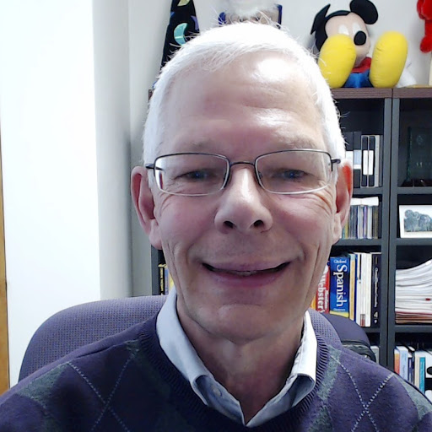
Jay Memmott earned a BA in English at the University of Utah, and both his MSW and PhD (in social work) at the University of Kansas. He has worked as a social worker in inpatient and outpatient mental health and substance abuse treatment settings, hospice and home health care, managed mental health care, and private practice since 1977. He started teaching full-time at the University of Oklahoma in 1989. In 1994, Jay joined the social work faculty at Saint Louis University. From July 2002 through July 2010, he served as the Department Chair and Director of the MSW Program at Washburn University. He is a member of the Academy of Certified Social Workers (ACSW), the National Association of Social Workers (NASW), and the Council on Social Work Education (CSWE). He is a site team visitor for the Council on Social Work Education (CSWE) and a past member of the Examination Committee for the Association of Social Work Boards (ASWB). Jay’s current research and scholarly interests include health and mental health literacy, substance abuse, natural helping, and behavioral change.

